Practice Exercise for Pseudocode and Flowchart

Try to write algorithm (Pseudocode) and draw the flowcharts for solving the following programming problems.
- Algorithm & flowchart to find Area and Perimeter of a Rectangle.
Area = L X W
Perimeter = 2X(L+W)
  - START
  - Input Side length and Width (L & W)
  - Area = L X W
  - Perimeter = 2 X(L+W)
  - Print Area and Perimeter
  - Stop
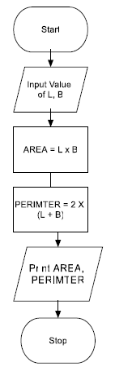

- Algorithm and Flowchart to swap two numbers using temporary variable.
  - Start
  - Input Two Numbers Num1, Num2
  - Declare Temp Variable
  - Temp = Num1
  - Num1 = Num2
  - Num2 = Temp
  - Display Num1 & Num2
  - Stop

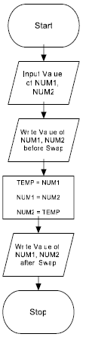
- Algorithm & flowchart to find the largest of three numbers.

a) start
b) read three numner num1, num2, num3
c) Declare largestnum = 0
d) if num1 > num2 and num1 > num3
largestNum = num1
else if num2 > num1 and num2 > num3
largestNum = num2
else:
largestNum=num3
e)print(largestNum)
f)stop
- Algorithm & flowchart to find even number between 1 to 50.
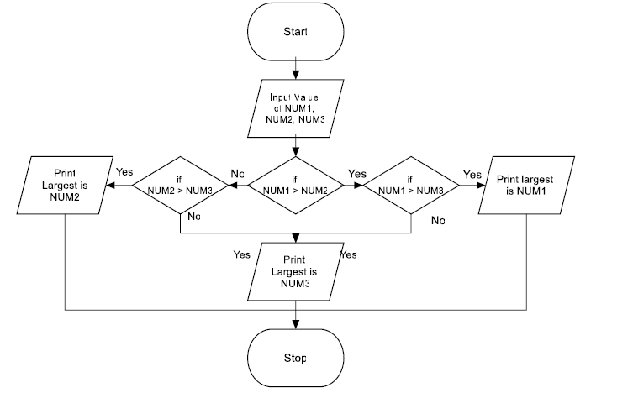
- Algorithm & Flowchart to find sum of series 1 – X + X² –X³ ….X^{N}
  - Start
  - Input N & X from the user
  - Declare Sum = 1, I = 1, Term = 1
  - If (I>N) then go to step 9 else continue
  - Term = -Term * X
  - Sum = Sum + Term
  - I = I + 1
  - Go to step 4
  - Display Sum
  - End
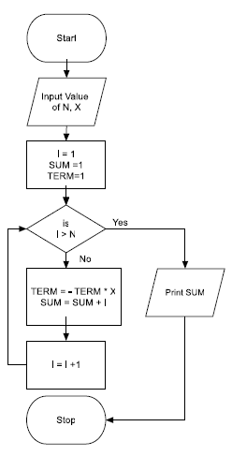
- Algorithm & Flowchart to generate first n Fibonacci (fee buh na chee) terms 0,1,1,2,3,5…n (n>2)
  - Start
  - Input value of N
  - A = 0, B = 1, Count = 2
  - Write A & B
  - If Count >N then go to step 12 (stop)
  - Next = A+B
  - Write Next
  - A = B
  - B = Next
  - Count = Count +1
  - Go to step 5
  - Stop
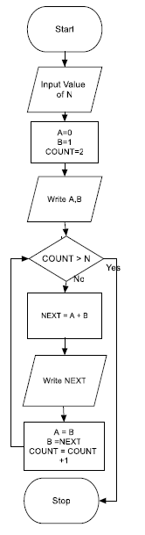
- Algorithm & Flowchart to find Roots of Quadratic Equations AX2+BX+C=0

If D < 0:
The equation has no real roots (complex roots), so output a message indicating this and terminate.
If D = 0:
The equation has one real root (a repeated root), so proceed to calculate the root.
- Calculate the single root: x = -b / (2a).
- Output the root.
If D > 0:
The equation has two distinct real roots, so proceed to calculate both roots.
- Calculate the first root: x1 = (-b + sqrt(D)) / (2a).
- Calculate the second root: x2 = (-b - sqrt(D)) / (2a).
- Start
- Input A, B & C
- Disc = (B*B) – (4*A*C)
- If Disc<0 then
- Write roots are imaginary and Stop
- Endif
- If Disc =0 then
- Write roots are real and equal
- X1 = -B(2*A)
- Write roots and stop
- If disc>0 then
- Write roots are real and unequal
- X1 = (-B+sqrt(Disc))/(2*A)
- X2 = (-B-sqrt(Disc))/(2*A)
- Write roots and stop
- Stop

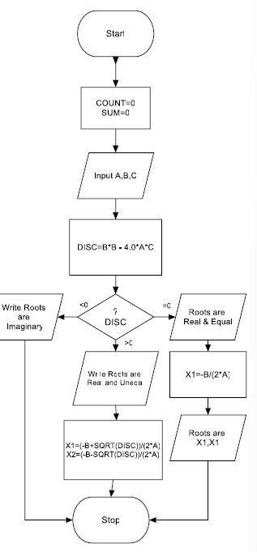
- Algorithm & Flowchart to find if a number is prime or not.
- 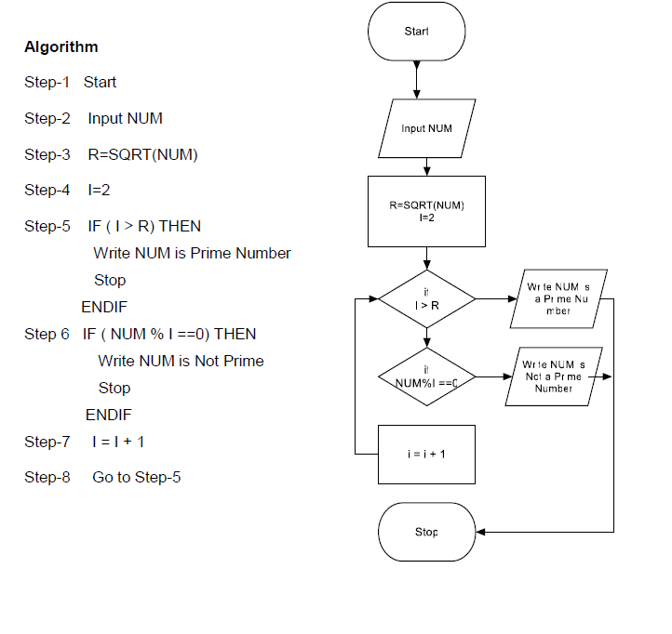

- Algorithm & Flowchart to find GCD and LCM of two numbers

- Two strings are anagrams if they are written using the same exact letters, ignoring space, punctuation and capitalization. Each letter should have the same count in both strings. For example, Army and Mary are anagram of each other.

